Create Routine AE Report
Technical Specification

Technical Specification

Version Histroy
Version | Date Modified | Author
 |  | Krikor Krumlian

Contacts and Support
KrikorKrumlian kkrumlian@akazaresearch.com | NA
NA | NA

LISTSERV Facilities Pertinent to software teams
LISTSERV | URL | Name
Caaersappdev-technical | caaersappdev-technical@gforge.nci.nih.gov. | caAERS technical forum
Table of Contents
1 Scope and Purpose 4
2 Overview 4
2.1 Features 4
2.2 Assumptions 4
3 Design Approach 4
3.1 Domain Objects 4
3.2 Persistence Layer 4
3.3 Service Layer 5
3.4 Controller Layer 5
3.5 View Layer 5
4 Implementation 5
4.1 Domain Model 5
4.2 Sequence Diagram 6
4.3 Activity Diagram 6
5 Testing 7
5.1 Domain Layer 7
5.2 Persistence Layer 7
5.3 Service Layer 7
5.4 Web Layer 7

List of Figures
Figure 1 5
Figure 2 6

Scope and Purpose

Overview
The purpose of this document is to outline the proposed technical of the Create Routine AE feature in caAERS. Where appropriate, the accompanying UML models and documentation have been included as part of this document.

Features
This feature allows users to create bulk routine reports. A Routine report consists of multiple Adverse Events.

Assumptions
In order to successfully create a routine report you need to have a study and participant assigned to each other.

Design Approach

Domain Objects
caAERS has a domain driven design with analysis starting from a BRIDG (Biomedical Research Integrated Domain Group) Harmonized model. A set of domain objects will be created in gov.nih.nci.cabig.caaers.domain. Once domain model is finalized, an immediate Implementation Model is based out of the domain model which identifies the Java classes, associations. The domain objects are persisted using Hibernate and Hibernate 3 annotations will be used for mapping to database elements instead of separate hbm files. These annotations can in turn be configured via Spring’s bean configuration files.

Persistence Layer
DAO implementations will be created to facilitate database access. The application will only access the database via a DAO interface object. Each implementation of the dao interface would a specific implementation (in this case, hibernate) which extend the org.Springframework.orm.hibernate3.support.HibernateDaoSupport class that provides a good template for quickly building data access methods without the risk of database leaks and poor error handling.

Service Layer
The service layer will expose a set of interfaces for the client to call in (currently the interface decided is a Web Interface). The Controller classes typically delegate the functionality to Service classes. Spring adds the dependency injection for the implemented classes as Controller need not be coupled with the SAM.

Controller Layer
Spring’s MVC is being used as the MVC architecture for caAERS. All the Controller classes for the respective use case will be located in the package gov.nih.nci.cabig.caaers.web

View Layer
The view technology incorporated in caAERS consists of JSP pages, css, AJAX and tag libraries included from Spring.

Implementation

Domain Model
Derived from Domain Analysis model, the implementation model is a model realized for a Java implementation with classes, associations. This model reflects the relation of a Routine Adverse Event with an Adverse Event
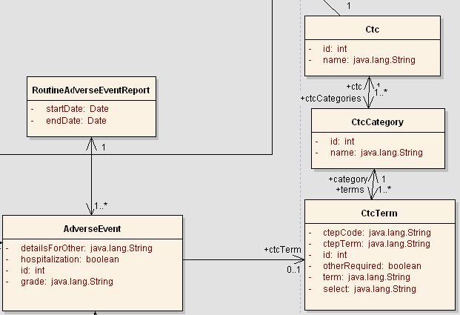
Figure 1

Sequence Diagram
Core controller of Create/Edit Study is based on Spring’s AbstractWizardFormController. This eliminates the session/form handling by the developer and provides fine extension points for generating a workflow between a well defined set of pages with the notion of back/next buttons. The validations used on the page are two level – client side javascript and server side Spring Validator validations (to be done only on the last page).The process of creating a routine report goes through 4 tabs.
Tab1 – choose study & corresponding participant
Tab2 – choose start and end date as well as ctc catgories
Tab3 – using these categories choose terms and add AEs
Tab4- Summary page and Save

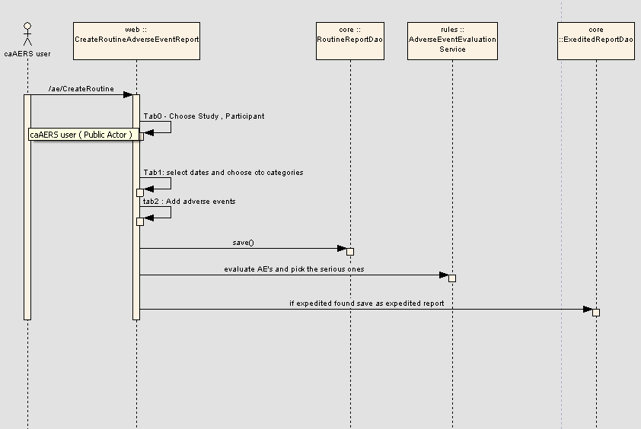

Activity Diagram
The workflow is a single page in a Create/ Edit Routine AE Report Wizard
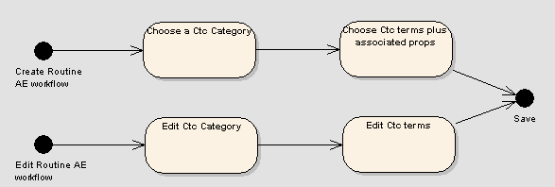
Figure 2

Testing

Domain Layer

Test Class Name | Target
gov.nih.nci.cabig.caaers.domain.RoutineAdvereseEventReportTest.java | Test the model

Persistence Layer

Test Class Name | Target
gov.nih.nci.cabig.caaers.dao.RoutineAdverseEventReportDao.java | Tests the RoutineAdverseEventReportDao class – this class is responsible in performing CRUD.

Service Layer

No service Layer code available for this feature

Web Layer

